**Annexure 2**

**Web Framework**

**CSL253**

Project Report



Faculty name:Dr.Neeti Kashyap Group Members: 1. Nishant Sharma ( 20CSU195 )

2. Nilesh( 20CSU210 )

3. Bhavesh Parmar( 20CSU215)

Semester: 5th

Group: FS-B

**Department of Computer Science and Engineering**

**The NorthCap University, Gurugram- 122001, India**

**Session 2022-23**

**Table of Contents**

|  |  |  |
| --- | --- | --- |
| **S.No** |  | **Page No.** |
| **1.** | **Project Description** | **3** |
| **2.** | **Problem Statement** | **3** |
| **3.** | **Analysis**  **3.1 Hardware Requirements**  **3.2 Software Requirements** | **4** |
| **5.** | **Output (Screenshots)** | **5-16** |
| **6.** | **Conclusion and Future Scope** | **17** |
|  |  |  |

**Project Description :**

The objective of this project is to build a Weather forecasting system using Angular framework , HTML , CSS , Javascript with MongoDB as database wherein the connectivity is provided using NodeJs.

In beginning of the application the user is provided with a home page where he can input the name of the particular city he wants to know about then he will be shown with the weather conditions of the city , the minimum and maximum temperature ,wind speed and humidity at the instance this data is fetched with the help of API names OpenWeather and after the search the record is saved in the mongodb for future reference.

**Problem Statement:**

Build a Weather recording and Monitoring system using Angular framework , HTML , CSS , Javascript with MongoDB as database wherein the connectivity is provided using NodeJs. Weather recording and Monitoring system provides the weather of different cities just by sitting at home.

**Analysis**

**Software requirements:**

1. Visual Studio Code
2. OpenWeather API
3. MongoDB Compass

**Output (Screenshots)**

**Angular Project Output:**

**Homepage :-**

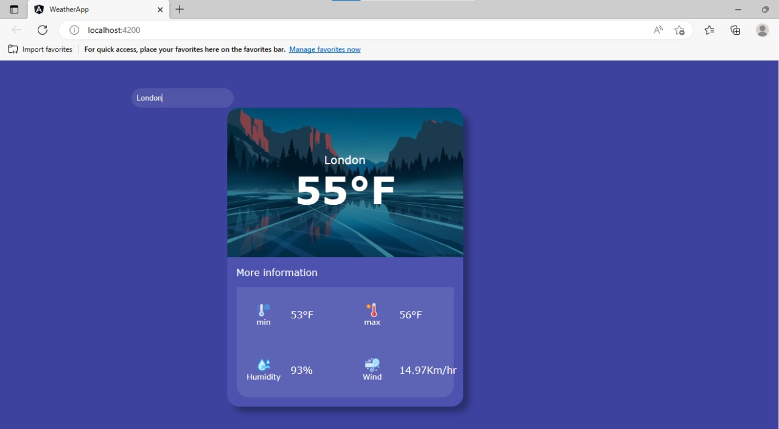

**When a record is added :-**

**Html code :-**

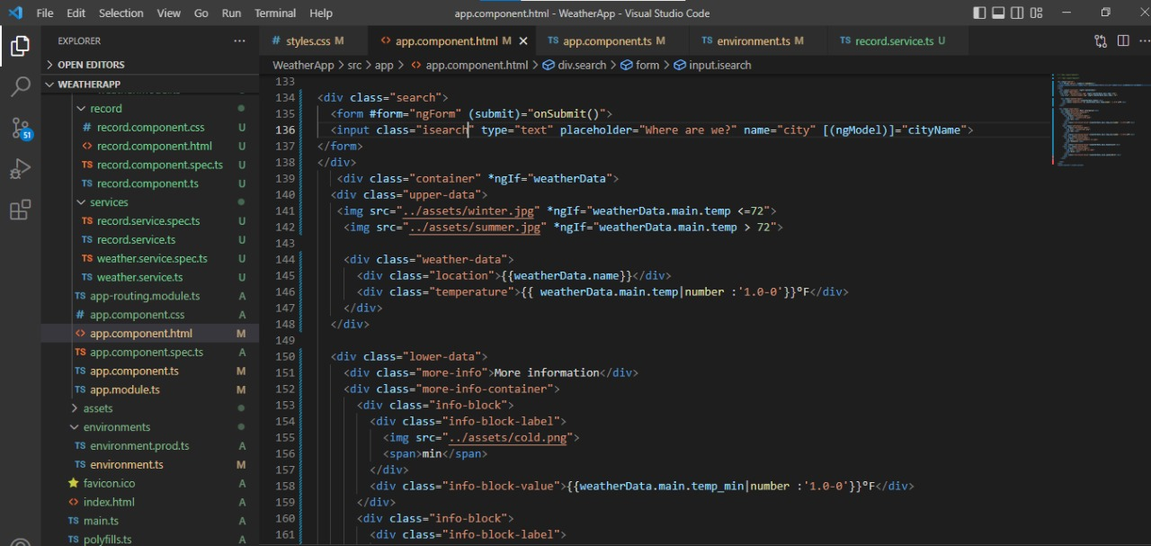

**CssCode :-**

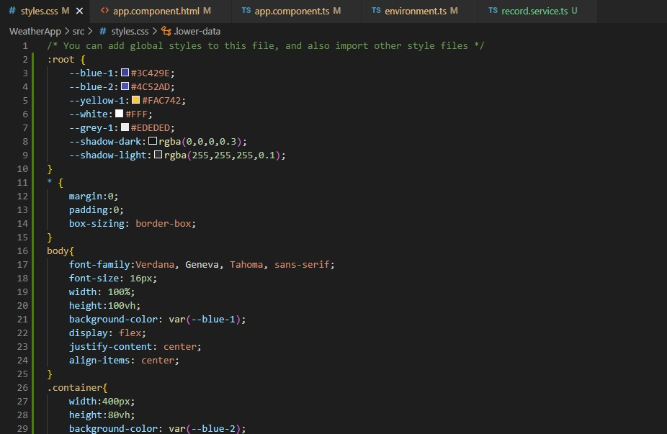

Component file :-

**JavaScript file:-**

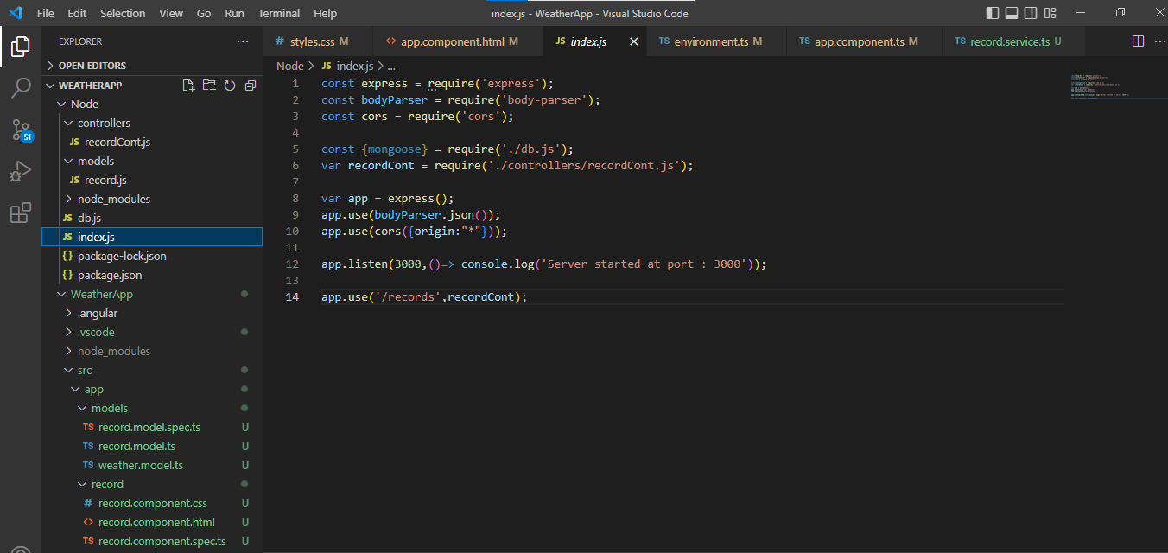

**Controllers File:-**

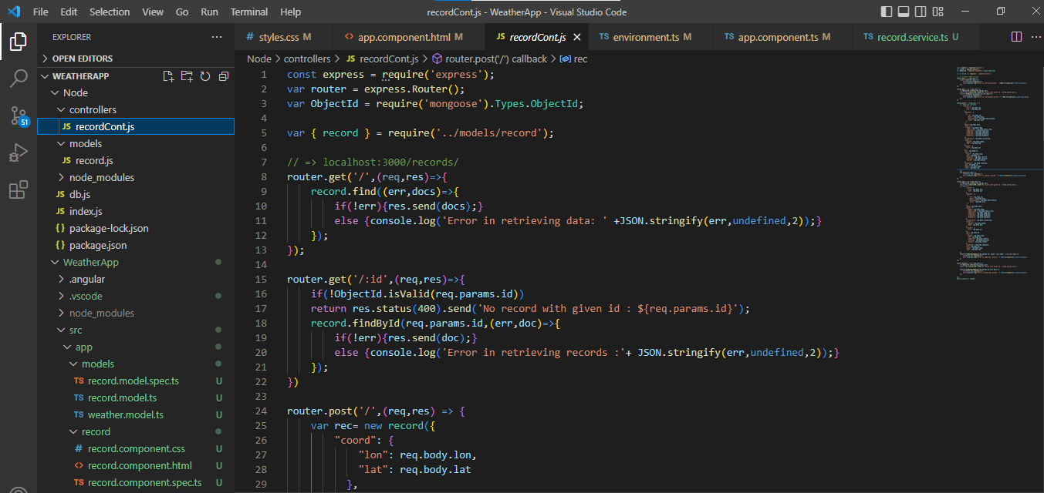

**Service file :-**

**Record service**

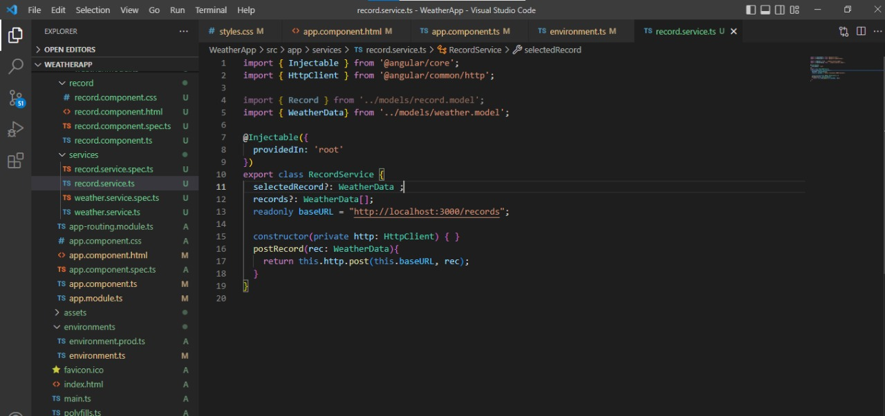

**Weather service**

**Environments File:-**

**Database record of weather conditions:**

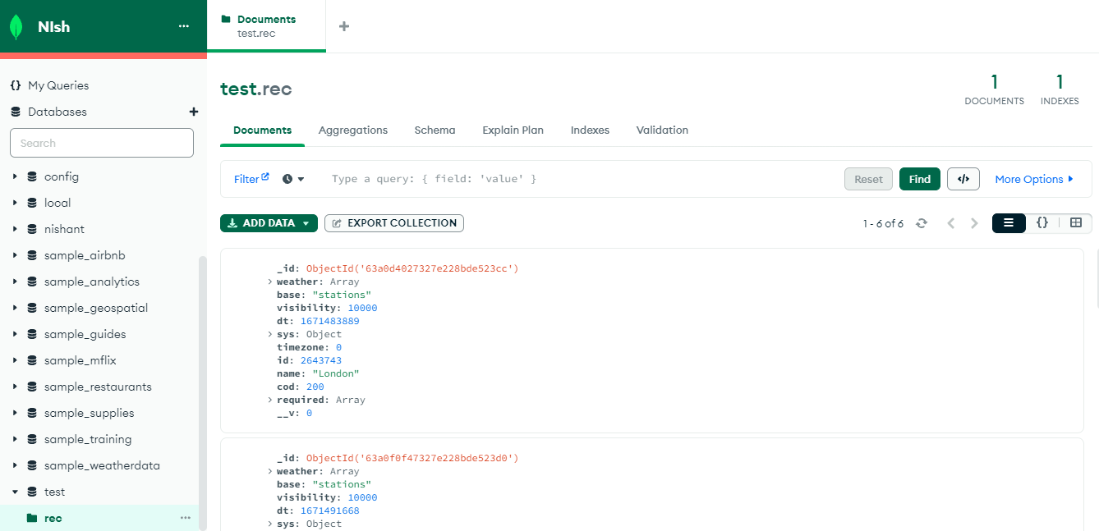

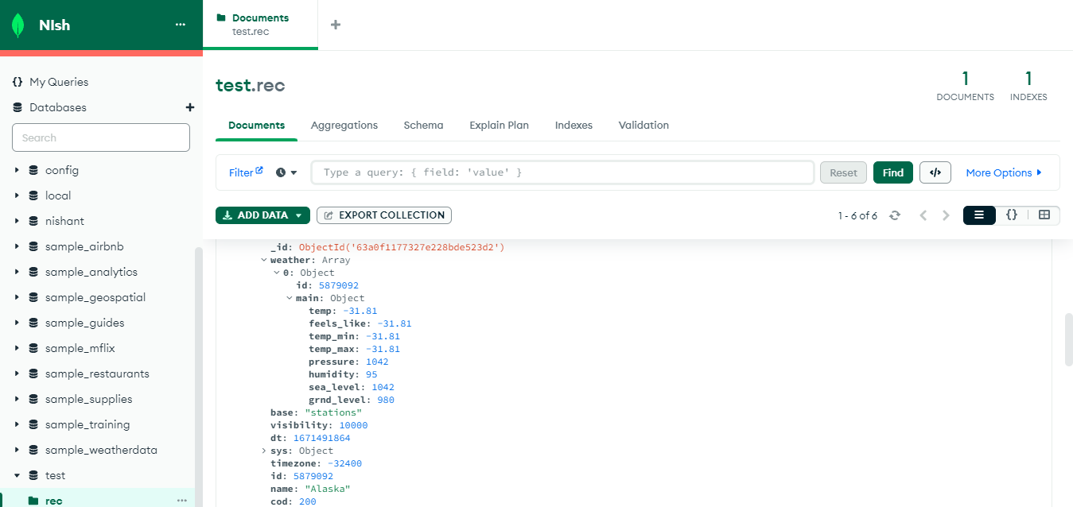

**Conclusion:**

Our project is only a humble venture to help users to know about the weather conditions of different cities and store their results for further help in future , it also helps in finding the minimum and maximum temperature of the city the wind speed and humidity in the weather.